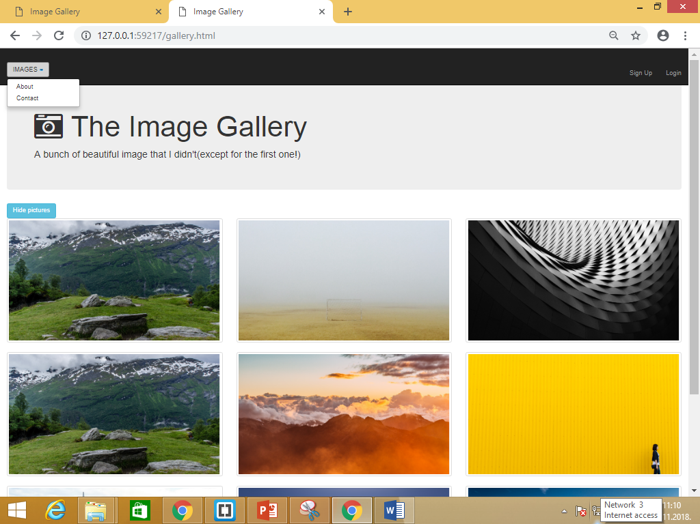

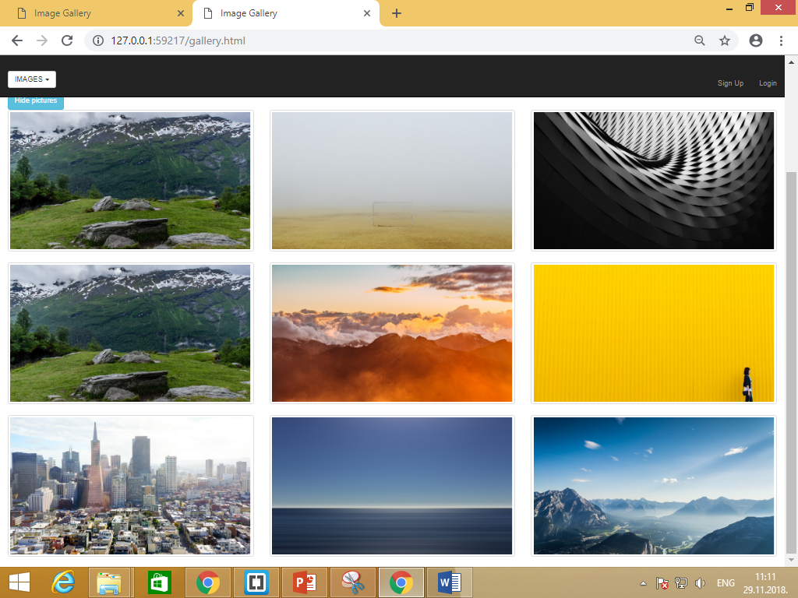

Na klik dugmeta potrebno je da se sve slike sakriju

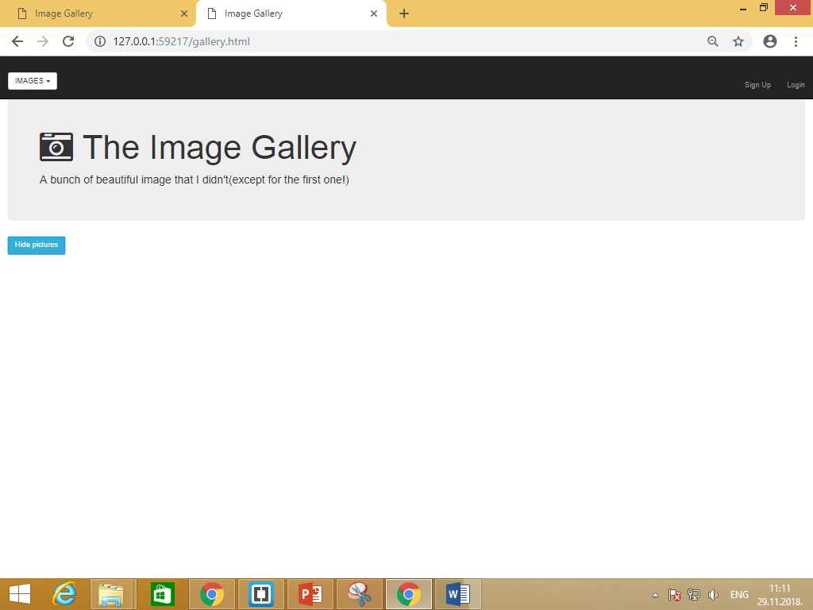

Izgled stranice kada je sirina preko 1200 px

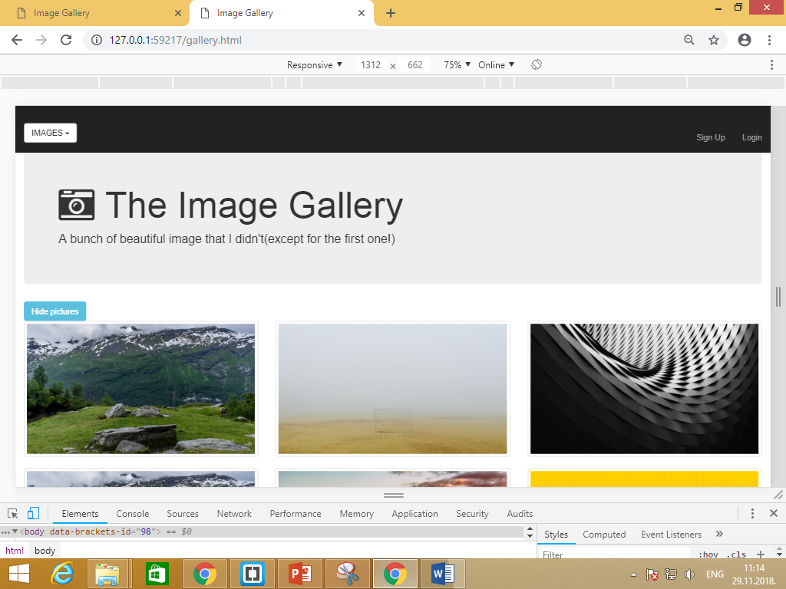

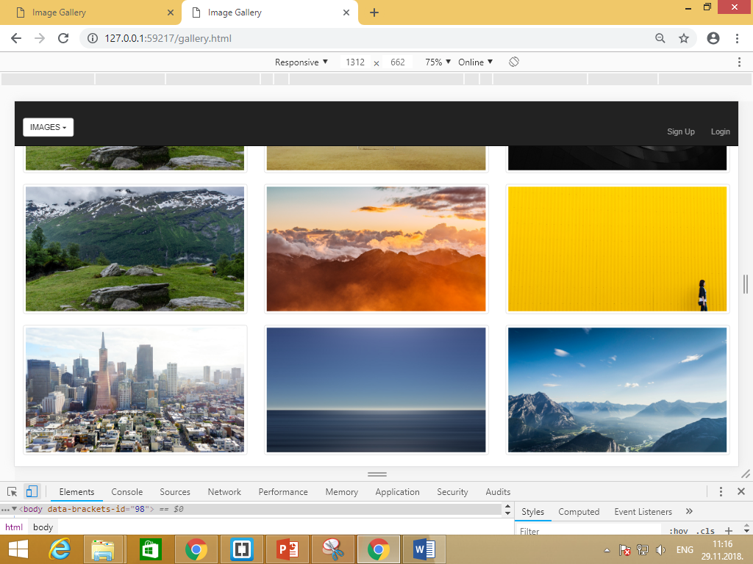

Izgled stranice kada je sirina >=768 px

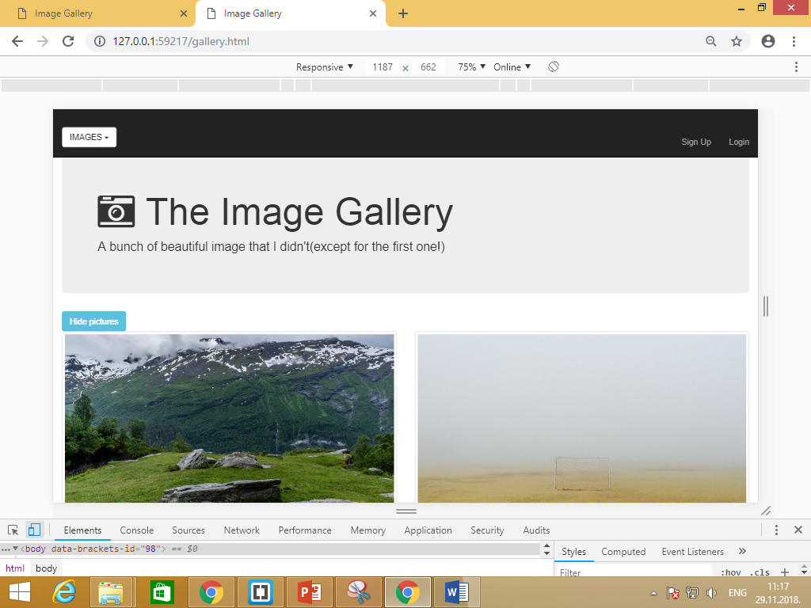

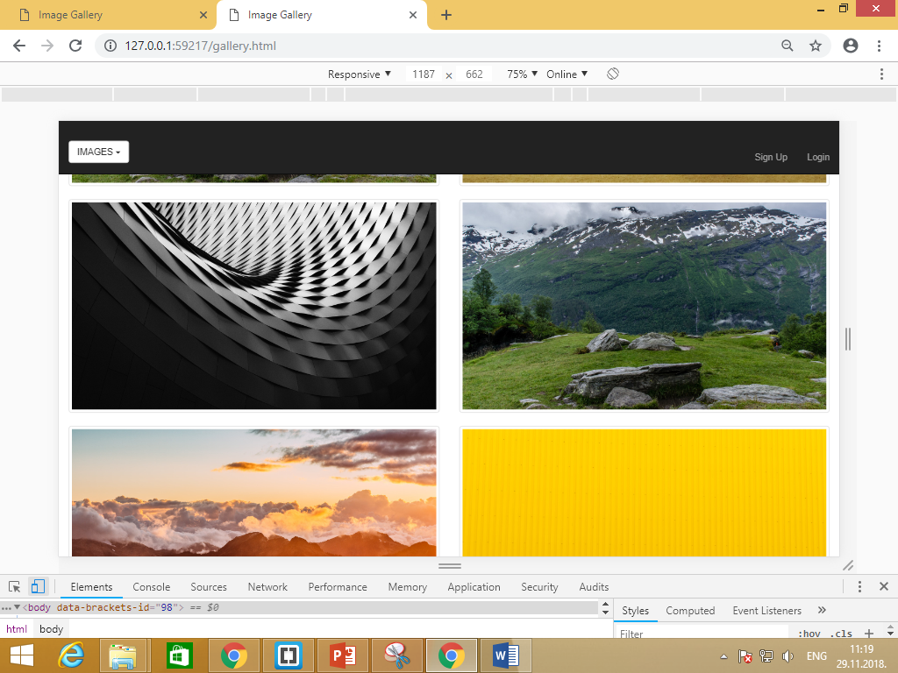

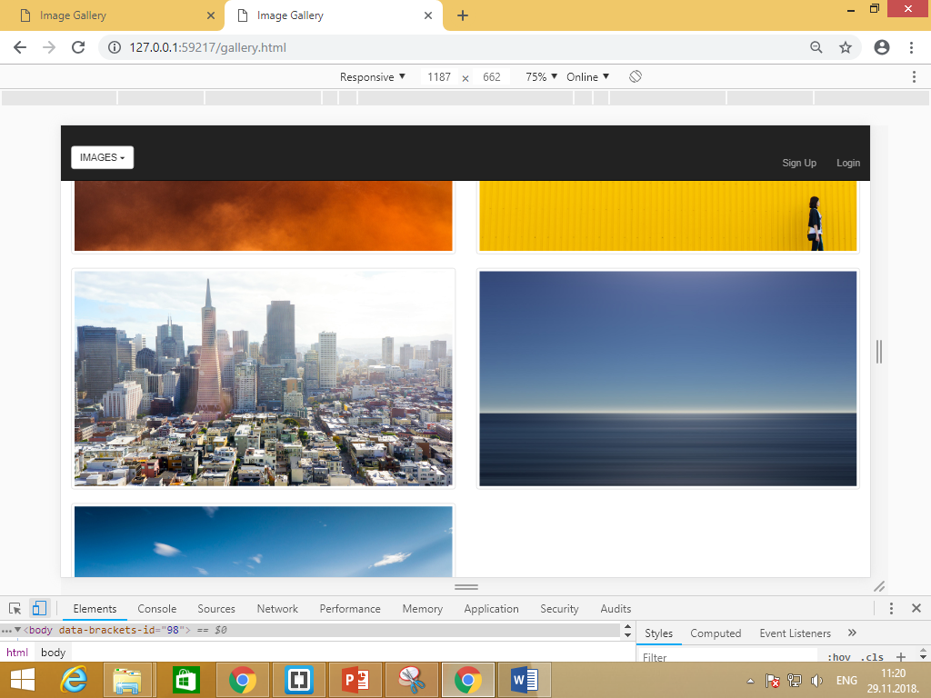

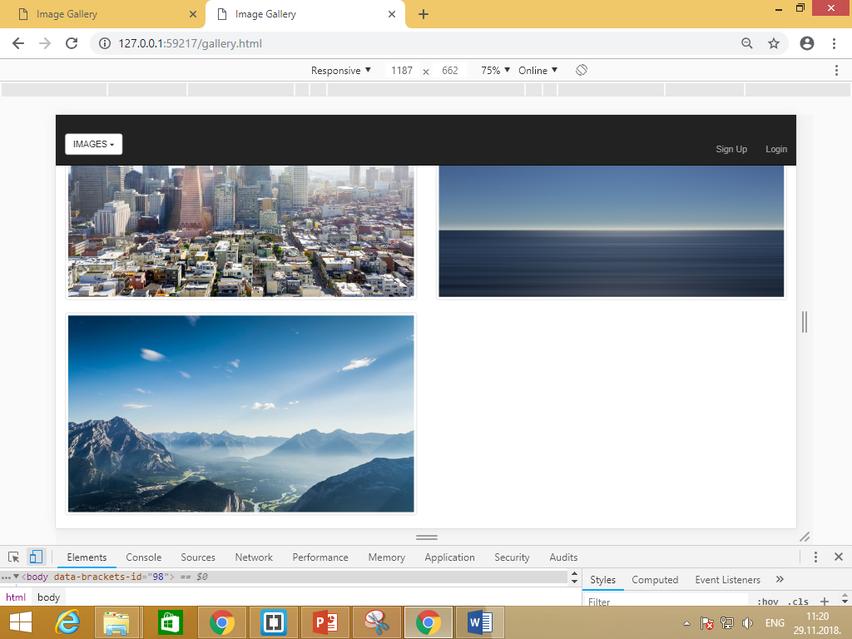

**Linkovi koji su potrebni za ubacivanje slika**

<https://images.unsplash.com/photo-1439524970634-649c37a69e5c?ixlib=rb-0.3.5&q=80&fm=jpg&crop=entropy&w=1450&h=825&fit=crop&s=bfda9916c885869b43b70738693428d9>

<https://images.unsplash.com/photo-1435771112039-1e5b2bcad966?dpr=2&fit=crop&fm=jpg&h=825&q=50&w=1450>

<https://images.unsplash.com/photo-1442406964439-e46ab8eff7c4?dpr=2&fit=crop&fm=jpg&h=825&q=50&w=1450>

<https://images.unsplash.com/photo-1439524970634-649c37a69e5c?ixlib=rb-0.3.5&q=80&fm=jpg&crop=entropy&w=1450&h=825&fit=crop&s=bfda9916c885869b43b70738693428d9>

<https://images.unsplash.com/photo-1444090542259-0af8fa96557e?dpr=2&fit=crop&fm=jpg&h=825&q=50&w=1450>

<https://images.unsplash.com/photo-1436262513933-a0b06755c784?dpr=2&fit=crop&fm=jpg&h=825&q=50&w=1450>

<https://images.unsplash.com/photo-1439396087961-98bc12c21176?dpr=2&fit=crop&fm=jpg&h=825&q=50&w=1450>

<https://images.unsplash.com/photo-1434543177303-ef2cc7707e0d?dpr=2&fit=crop&fm=jpg&h=825&q=50&w=1450>

<https://images.unsplash.com/photo-1439694458393-78ecf14da7f9?dpr=2&fit=crop&fm=jpg&h=825&q=50&w=1450>